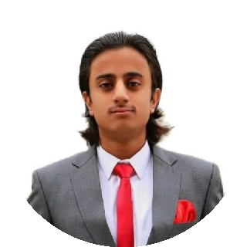






Khawaja Muhammad
Ibtisam
Personal details
Khawaja Muhammad Ibtisam ikhawaja523@gmail.com (+92) 3115958119
Rawalpindi, Pakistan October 3, 2003
https://www.linkedin.com/in/khawaja-ibtisam-297262319
Skills
Microsoft office Google Suite Primavera P6 PTV Vissim ETABS
SAFE
StaadPro AutoCAD Civil 3d ArcGIS 10.8
Communication

Languages
English Urdu

About me

A highly motivated and passionate Civil Engineer with a strong academic background from UET Taxila. Proven leadership and management skills, with a solid foundation in civil engineering principles and practices. Dedicated to delivering high-quality results and driving projects forward with enthusiasm and expertise. Eager to apply my skills and knowledge to contribute to innovative and impactful projects in the field of civil engineering.

Education
BSc. Civil Engineering 2021 - 2025
University of Engineering and Technology, Taxila CGPA : 2.86/4

Work Experience

Intern Jul 2024 - Aug 2024
Defence Housing Authority(DHA), Rawalpindi/Islamabad
•Assisted in engineering design, project planning, and site supervision of Phase III Main Mosque construction.
•Applied theoretical knowledge to real-world engineering challenges, including material assessment, and construction methodologies in the construction of a Lake in Phase III of DHA.
•Conducted technical evaluations and reviewed project drawings of the Mosque, reviewing its design accuracy and compliance with industry standards.
Intern Aug 2023 - Sep 2023
Astral Constructors (pvt) Ltd., Gujar Khan
Assisted in site supervision of construction site in New Metro City Gujar Khan.
Director Management Aug 2024 - May 2025 Institute of Civil Engineering-Chapter UET Taxila
•Manage society operations, coordinating events, hosting seminars, and industry collaborations.
•Lead diverse teams to plan and execute technical events like CIVCon, developing leadership and project management skills.
President Jul 2024 - May 2025
Pothohar Engineering Community, UET Taxila
Provided leadership and strategic direction for the Pothohar Engineering Community, representing students from the Pothohar region.
Organized and successfully led a Ramadan Iftar drive.

Certificates
President of Pothohar Engineering Community Jul 2024
Director Management of ICE Cabinet Aug 2024
One Day Awareness Workshop on ArcGIS Dec 2021

Final Year Project
Conversion of signalized intersection into roundabout and studying its impact on nearby junction
Used PTV Vissim for designing and simulation of Signalized and roundabout intersections

